**1.CAPITAL**

%%

[A-Z]+[\t\n ] { printf("%s is a capital word\n",yytext); }

. ;

%%

int main( )

{

printf("Enter String :\n");

yylex();

}

int yywrap( )

{

return 1;

}

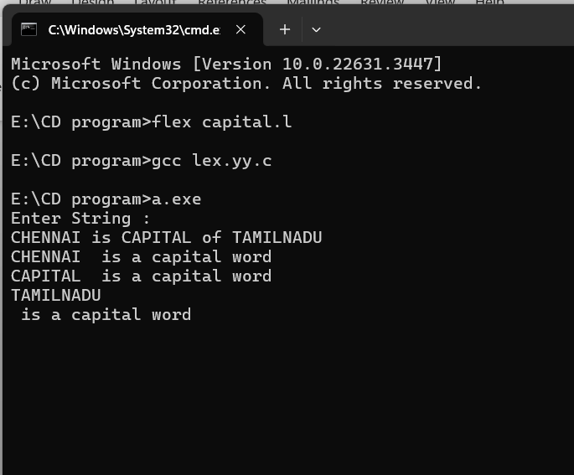

**2.digit or not**

%%

[0-9]+ {printf("\nValid digit \n");}

.* printf("\nInvalid digit\n");

%%

int yywrap(){}

int main()

{

yylex();

return 0;

}

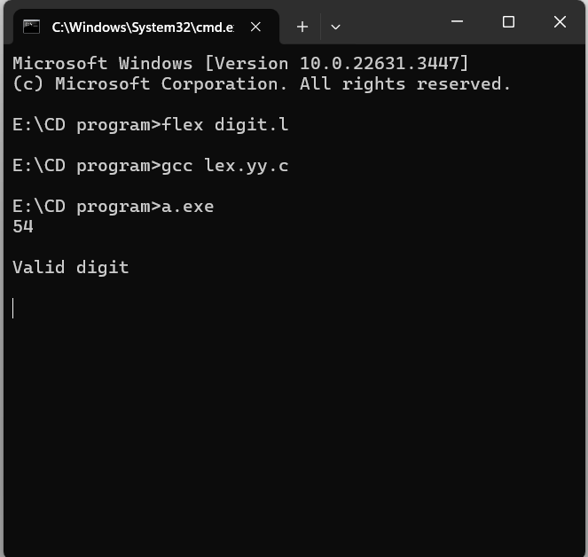

**3.mobile number**

%%

[1-9][0-9]{9} {printf("\nMobile Number Valid\n");}

.+ {printf("\nMobile Number Invalid\n");}

%%

int main()

{

printf("\nEnter Mobile Number : ");

yylex();

printf("\n");

return 0;

}

int yywrap()

{ }

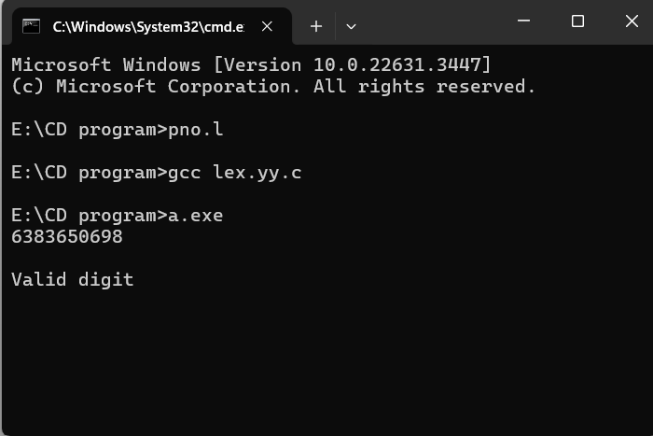

**5.keywords and identifiers**

digit [0-9]

letter [A-Za-z]

%{

int count_id,count_key;

%}

%%

(stdio.h|conio.h) { printf("%s is a standard library\n",yytext); }

(include|void|main|printf|int) { printf("%s is a keyword\n",yytext); count_key++; }

{letter}({letter}|{digit})* { printf("%s is a identifier\n", yytext); count_id++; }

{digit}+ { printf("%s is a number\n", yytext); }

\"(\\.|[^"\\])*\" { printf("%s is a string literal\n", yytext); }

.|\n { }

%%

int yywrap(void) {

return 1;

}

int main(int argc, char *argv[]) {

yyin = fopen(argv[1], "r");

yylex();

printf("number of identifiers = %d\n", count_id);

printf("number of keywords = %d\n", count_key);

fclose(yyin);

}

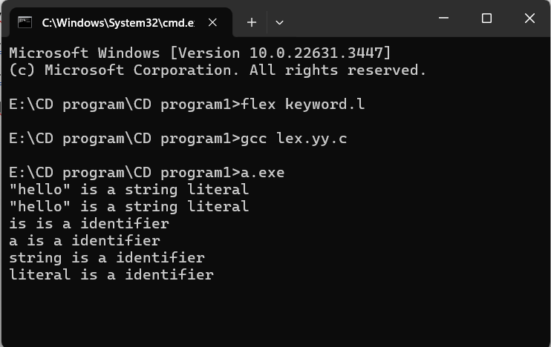

**6.positive and negative**

%{

int positive_no = 0, negative_no = 0;

%}

%%

^[-][0-9]+ {negative_no++;

printf("negative number = %s\n",

yytext);} // negative number

[0-9]+ {positive_no++;

printf("positive number = %s\n",

yytext);} // positive number

%%

int yywrap(){}

int main()

{

yylex();

printf ("number of positive numbers = %d,"

"number of negative numbers = %d\n",

positive_no, negative_no);

return 0;

}

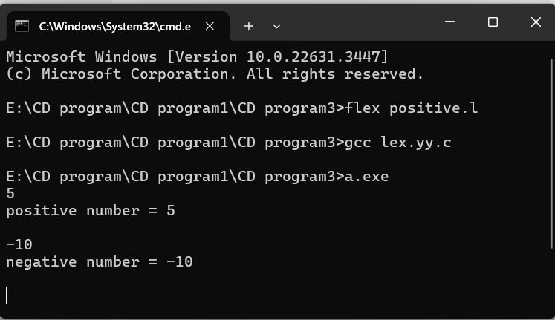

**7.words and numbers**

%%

[\t ]+ ;

[0-9]+|[0-9]*\.[0-9]+ { printf("\n%s is NUMBER", yytext);}

#.* { printf("\n%s is COMMENT", yytext);}

[a-zA-Z]+ { printf("\n%s is WORD", yytext);}

\n { ECHO;}

%%

int main()

{

while( yylex());

}

int yywrap( )

{

return 1;

}

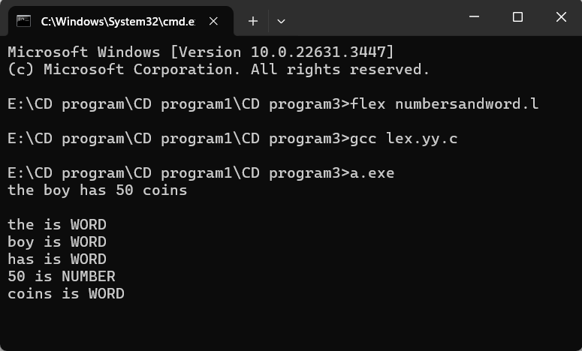

**8. accept string starting with vowel**

%{

#include <stdio.h>

%}

%%

^[aeiouAEIOU][a-zA-Z ]* { printf("String starts with a vowel: %s\n", yytext); }

.* { printf("Ignored string: %s\n", yytext); }

\n { /* Ignore newlines */ }

%%

int main(void) {

printf("Enter input strings (CTRL+Z to end):\n");

yylex();

return 0;

}

int yywrap(void) {

return 1;

}

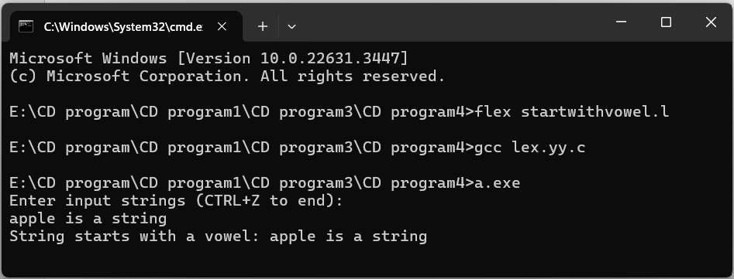

**4.vowels and consonants**

%{

#include <stdio.h>

int vow_count = 0;

int const_count = 0;

%}

%%

[aeiouAEIOU] { vow_count++; }

[b-df-hj-np-tv-zB-DF-HJ-NP-TV-Z] { const_count++; }

. { /* Do nothing */ }

%%

int main() {

printf("Enter the string of vowels and consonants:\n");

yylex();

printf("Number of vowels are: %d\n", vow_count);

printf("Number of consonants are: %d\n", const_count);

return 0;

}

int yywrap() {

return 1;

}

